The problem of the chopper with a broken belt can be a little difficult to diagnose if the upper belt broken. The motor still runs and you can hear the motor wind down when using the PMT plunger to stop it. Light just doesn’t get to the photo tube which is oftentimes diagnosed as an electronic or tube problem with lots of wasted troubleshooting time. Belts break so seldom though that most techs don’t know anything about belts in the chopper. Hopefully this will help.

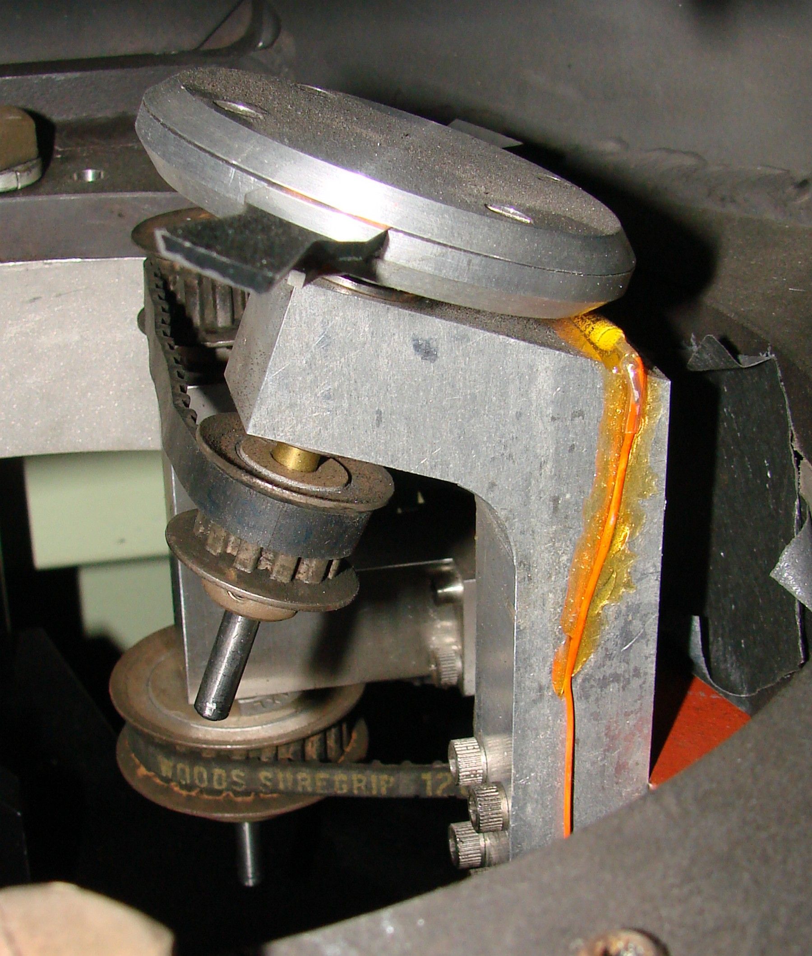
Chopper Assembly

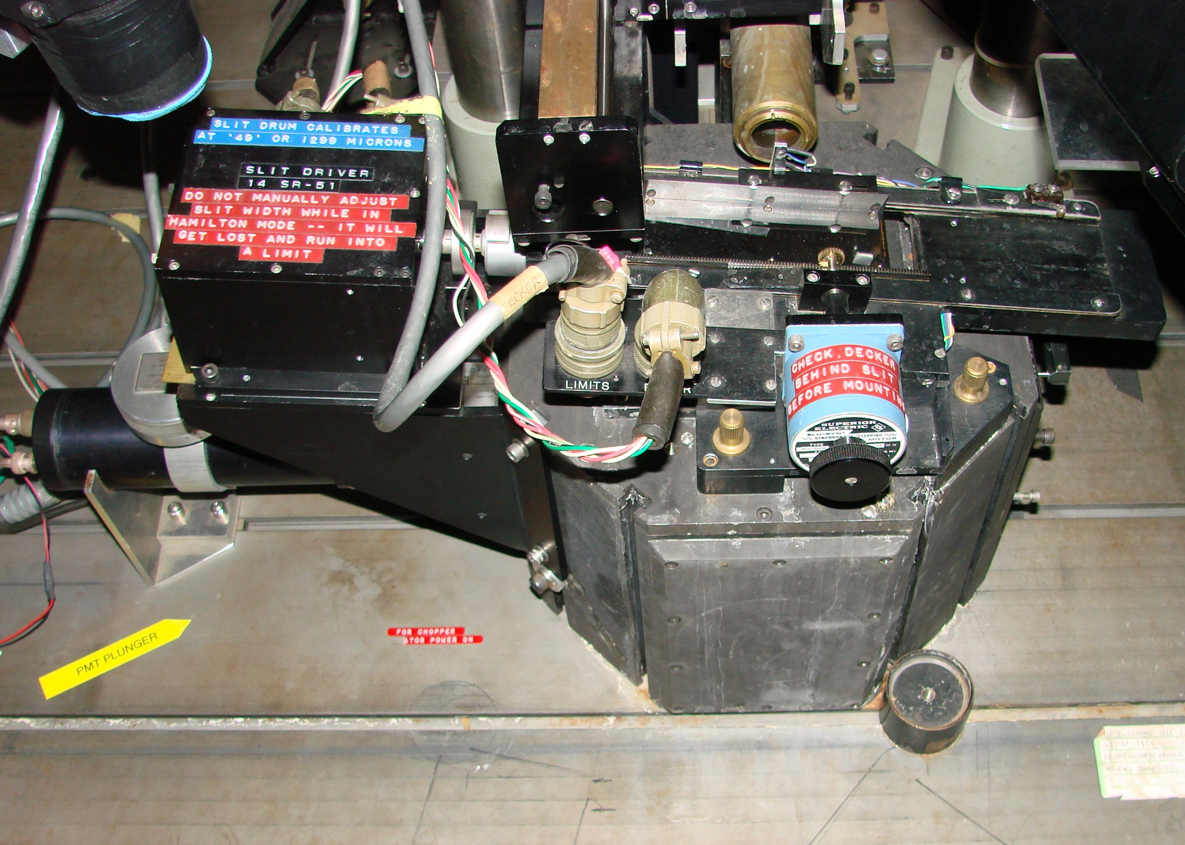
The chopper is inside of the Coude′ slit pedestal.

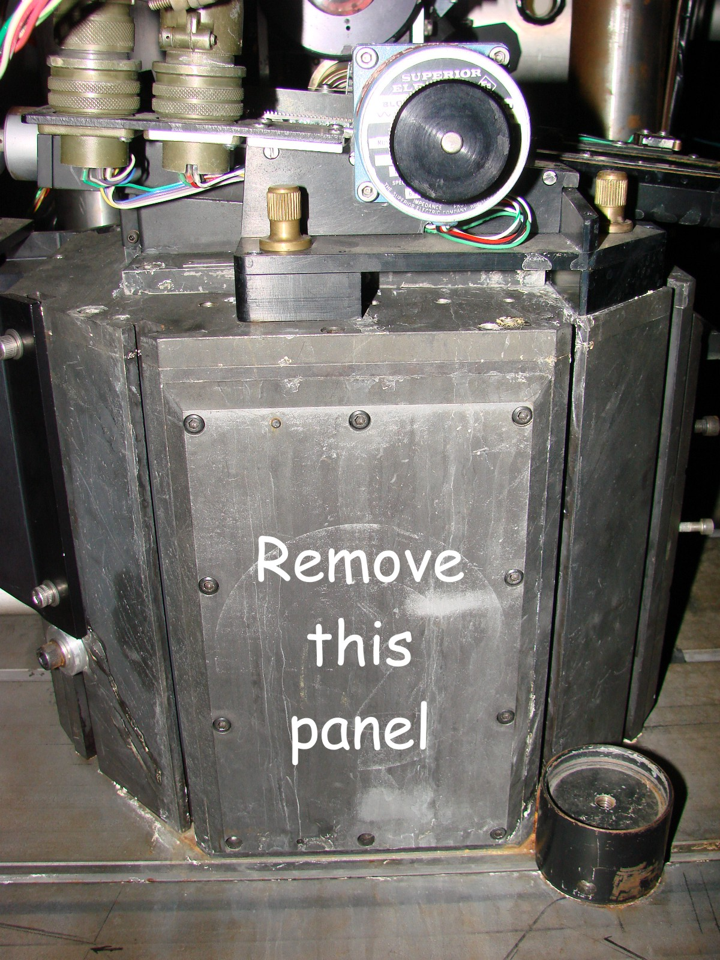
Remove the panel screws. The panel is pinned so some gentle prying will be needed.

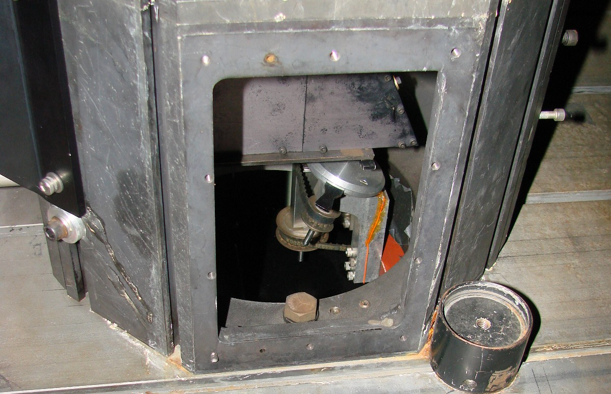
Cover removed.

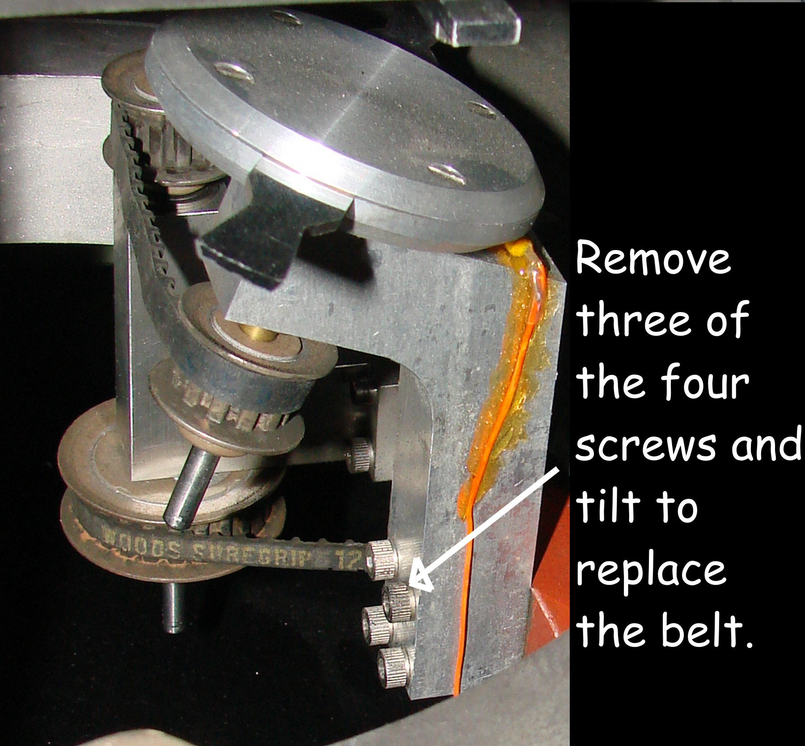
The lower belt is harder to get at.

There are two belts in series that drive the chopper. The lower belt goes from motor to jackshaft while the upper belt goes from the jackshaft to the chopper shaft that drives the chopper.
There is a start/stop chopper control knob (labeled PMT Plunger) on the left side of the pedestal. This pushes a thin metal rod into the motor pulley to stop it. Actual power to the motor is controlled by the electronics in the rack behind you.

The upper belt has #80/XL/025 on it. It has 40 teeth.
The lower belt says Woods Suregrip 12D (Need More Info.)

